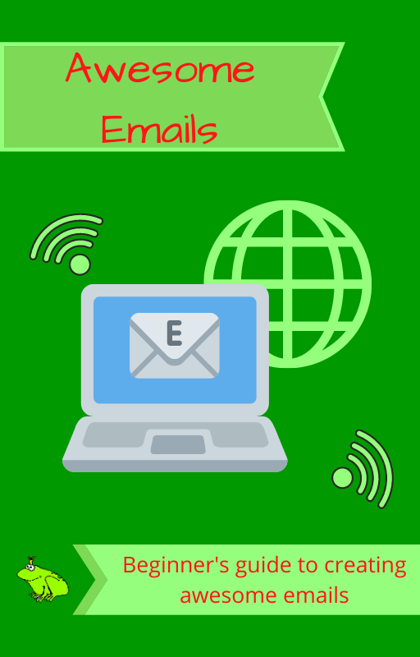

Copyright © 2021
William F. Woolverton

TABLE OF CONTENTS

Table of Contents
Introduction 4
Email Etiquette 5
Subject Line 6
Email Body 7
Your Call to Action 8
Avoid These Mistakes 9
Conclusion 10

Introduction

Email has always been one of the most powerful tools in an online marketer’s Arsenal But has also become important to brick and mortar business as well.
Writing highly effective messages that yield consistent results is not easy. However with a little learning curve, which requires a bit of practice. This guide will teach you all the basics you need to know. In order to write powerful emails that spur readers to take action.

You’ll learn about the common mistakes that most rookies do and how you can avoid them, as well, as how to write the perfect subject line, body content and call to action.

Email Etiquette

There are many unwritten rules and pitfalls to watch out for when writing your emails. Not only do you need to make sure you’re writing with proper grammar, but you must also be formal when the situation calls for it, and informal when it is more appropriate. You should try to include a suitable greeting and closing in all your of emails and, leaving them out looks very unprofessional.

Go easy on the amount of HTML formatting you use, as it can look completely different depending on the email client and type of device used by the recipient. The less formatting tags you use, the more consistent your email will look.

You should also be careful about attaching large files and images also. Always make sure to compress them down to the smallest possible file size, and resize images to suit smaller screens. You want to try and keep attachments (including images) below 5 MB for best results – otherwise some email servers might discard your emails before delivery.

Many email marketers and brick & mortar business are uncertain about how often they should email their subscribers. There are no hard rules here for how often to send an email. Some situations will call for emailing every day while others will do better with a once per month mailing. It’s more important to email your contacts consistently with a fixed interval than fretting over whether to email every 3rd or 5th day.

Subject Line

Writing awesome subject lines is an art form in itself, one that can take many years of experimentation to fully master. However, there are a few best practices that when followed should produce some awesome open rates for you.

First things first, the best subject lines are short and punchy, ideally less than 50 characters in length. You want to tease the reader and raise their curiosity. It is often a good idea to mention something about what they can expect in the email.

Personalized subject lines also do extremely well in most situations, but it’s no longer as simple as just inserting the recipient’s name and thinking that will do it. That trick has been done so long and so much that it is played out, but it doesn’t mean that there is not room for other types of personalization.
Example: mentioning the city they live in, if that data is available.

You should also try to avoid using hype as most people have grown immune to it. Now unbelievable claims, subject lines in all caps or excessive use of exclamation marks mostly trigger their “spam radar”. Scarcity techniques like “only 24 hours to act” and similar still work though, but it needs to actually be true and the message itself needs to back it up.

The very best way to find your winning subject lines is to split test them against each other. One great technique for this is sending out Subject line A to 25% of your list, and Subject line B to another 25%. Then pick the winner of those two and use that for the remaining 50%. This does require you to have a reasonably sized list for this though, or the results will not be statistically significant.

Email Body

One of the best ways to ensure people actually read your email is to make it short and to the point. Emails are not great for long-form content as people will often just scan them. If you still want to include a long article or something like that. It is much better to just use the email as a teaser and then have them click on a link leading to the content to continue reading.

You need to always keep your readers in mind when writing your emails body content. Think about what They Want to read, learn about, or problem you can solve and you will have no problem constructing something useful. The more value you can offer in your emails the better results you will see from your efforts.
Hint: Try to include the best parts as early as possible in your messages. As you can then “hook” your users and keeps them reading the rest of your email.

When people subscribe to an email list, they often have a picture in their mind of what kind of content they expect. To ensure they stay interested and engaged, always try to keep your content relevant to the original topic they signed up to get more information about.
Attention: If you stray too far from it they are highly likely to unsubscribe and go elsewhere.

Other than that, it is mostly a matter of trying to write in a clear, concise manner. You need to speak directly to your readers and write as if you are writing an email to a friend. Those types of emails usually get a much better result than a boring “newsletter” without a hint of any personality in them. And, as always, go easy on the formatting and try to keep it to a minimum.

Your Call to Action

You should always have the desired outcome in mind when writing your emails. Do you want the reader to click on a link, download a file, or maybe even buy something from you? The trick to getting readers to do what you want is to including a powerful “call to action” in your messages. It is exactly what it sounds like – you simply tell the reader what you want them to do.

The most effective call to actions are those that are very clear and simple to understand. They should also be relevant to the subject and content of the email, of course. Try to use simple language and imply that what the user is looking for is just a click away (for example “Buy now – click here” or “Download instantly”).
The ideal call to action requires very little effort from the reader and is a low-‐friction offer.
Example: A call to action that says “Register now to continue reading” has quite a lot of friction. For a user to bother with that it really needs to be something special, otherwise they just won’t click.

An awesome way to draw attention to your call to action is making it a big button that readers just can’t miss. You can also include it more than once in your emails, combining regular links embedded in the content with a big call to action at the end.

Something you want to consider is that while getting a good click-‐through rate on your call to action is important, it is not the only metric that matters. Even if 99% of your readers click on it, if no one takes the desired action after clicking it is still a failure.

Avoid These Mistakes

As I stated earlier, there are many potential pitfalls in email marketing. Some people actually make these mistakes again and again, never learning or improving. Make sure you are not one of them!

One of the most common mistakes email list owners make (both marketers and brick & mortar) is not sending out emails on regular intervals. What usually happens is you forget about it for a while, or you just don’t have the time to send something out (I’ve been bad about this), and with each passing day your list decays. Then when you finally get around to sending something out, most of your subscribers will have forgotten about your emails entirely. Your subscribers will not exactly welcome your email with open arms (unless the content is exceptional – sending out a highly promotional email after a long hiatus is definitely not recommended).

Another common mistake (both marketers and brick & mortar) is treating your list like a cash cow, milking it as hard as possible without any thought of providing any real valuable content to the subscribers. That may work for a short while, yes, but if you are not also constantly adding new subscribers the list will be useless sooner rather than later. List owners (both marketers and brick & mortar) who mostly send out solo ads and do ad swaps also risk falling into this trap if they’re not careful, burning out your list prematurely.
(Solo ads and ad swaps for brick & mortar businesses is done threw and with your local businesses area)
Finally, do not make the mistake of trying to hide the link that allows your subscriber to unsubscribe. It will not do you any good as people will just report your emails as spam and that can hurt your business, if they can not unsubscribe from your list.

Conclusion

Hopefully you now have a better understanding on what it takes to write effective emails that yields results. As you have seen it is not “just” about writing the perfect subject line or call to action, but rather ensuring that all the parts of your email are working in tandem. A good subject line entices the subscribers to open your email, an engaging body copy will sells them on what you have to offer, with a powerful call to action gets them to act now.
In order to become a highly successful email marketer you will need to learn how to experiment and test new things. By experimenting and looking at your stats (open rates, click-‐through rates, conversion rates, etc) you are able to uncover exactly what works best for your list. That is how you take your email marketing effort from good to exceptional!

